$$Decision Tree$$

$read the data$

$Preprocess the data or EDA$

$Model development$

$Evaluate the model$

$Hyper parameter Tune the model$

$Deployment$

$$Modeldeployment$$

$$1) Linear regression: Regression$$

$equation$

$How to find the coeff$

$RSE Rsq adjRsq$

$Hypothesis$

$Assumptions$

$$2) Logistic Regression:Classification$$

$Probability are very important$

$Sigmoid function$

$Logistic regression non linear form$

$Logistic regression in the Linear form$

$Log odds ratio$

$$Decision Tree$$

$$The name says: It is a tree kind of structure$$

$Roots$

$Branches$

$Leafs$

$$The main goal in DT is select the root node$$

$$Root node, branch nodes are columns$$

$$Leafs are outputs$$

$$Dont know much information=== >Randomness of information$$

$$sahil and pankaj both are good friends$$

$$In pankaj family one will happens in soon$$

$$one day pankaj called to shail: invitation and work$$

$$know the information so no random ness$$

$$pankaj called to sahil at 1am:panic$$

$$no information=====more random ness$$

$$ind vs aus =====win?$$

$$no particular information====more randomness$$

$$ind vs zim ===== > clear information===less randomness$$

$$shannon information creteria$$

$$Entropy:will tell about which information is more valuble$$

$$Entropy is very high$$

$$More randomness====information is not clear===Entropy is very high$$

$$H= -\sum_{i=1}^{n}{p_{i}*\log_{2}{p_{i}}}$$

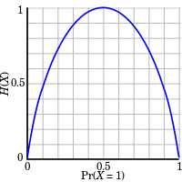

$$Toss a coin$$

$$P\left(head\right)=0.5, P\left(trail\right)=0.5$$

$$H= -\sum_{i=1}^{n=2}{p_{i}*\log_{2}{p_{i}}}$$

$$H={-p}_{1}*\log_{2}{p_{1}-p_{2}*\log_{2}{p_{2}}}$$

$$H={-p}_{head}*\log_{2}{p_{head}-p_{tail}*\log_{2}{p_{tail}}}$$

$$H=-0.5*\log_{2}{0.5-0.5*\log_{2}{0.5}}$$

$$H=-k-k=-2k=-2\left(0.5*\log_{2}{0.5}\right)=-1*\log_{2}{0.5=-1*-1=1}⁡$$

$$\log_{2}{1/2}=\log_{2}{2^{-1}}=\log_{a}{a^{m}}=m*\log_{a}{a}=m$$

$$\log_{2}{0.5}=\log_{2}{2^{-1}}=-1\log_{2}{2}=-1$$

$$H=[-0.5*-1]{-\left[0.5*-1\right]}$$

$$H=0.5+0.5=1$$

$$More random ness===No clarity===More Entropy$$

|  |  |  |
| --- | --- | --- |
| $$id$$ | $$age$$ | $$Buys computer$$ |
| 1 | Y | N |
| 2 | Y | N |
| 3 | MA | Y |
| 4 | S | Y |
| 5 | S | Y |
| 6 | S | N |
| 7 | MA | Y |
| 8 | Y | N |
| 9 | Y | Y |
| 10 | S | Y |
| 11 | Y | Y |
| 12 | MA | Y |
| 13 | MA | Y |
| 14 | S | N |

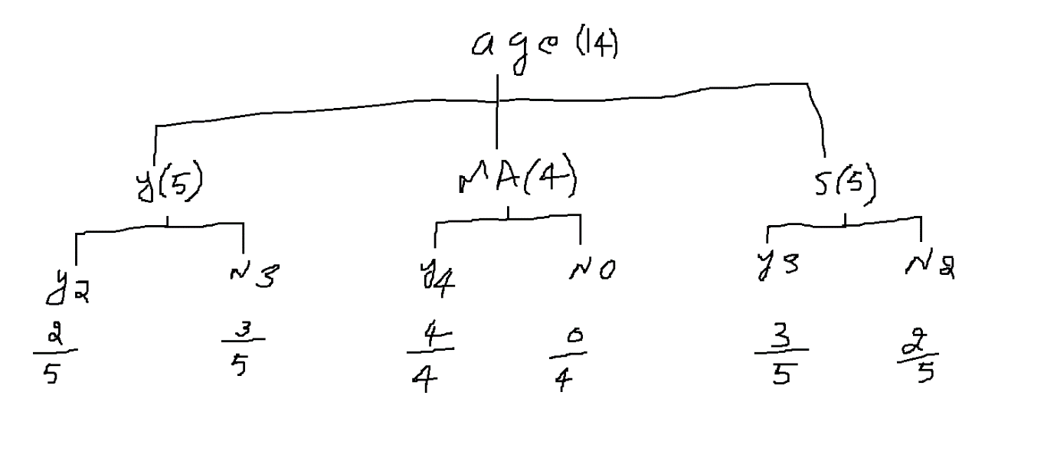

$$Step-1:(Individual column entropy)$$

$$Entopy of Age: H\left(Age\right) or H_{age}$$

$$H_{age}=H_{youth}+H_{MA}+H_{senior}$$

$$H_{youth}=two outcomes yes and No$$

$$H_{youth}=-p_{yes}*\log_{2}{p_{yes}}-p_{no}*\log_{2}{p_{no}}$$

$$H_{youth}=-\frac{2}{5}*\log_{2}{\frac{2}{5}}-\frac{3}{5}*\log_{2}{\frac{3}{5}}$$

$$H_{MA}=two outcomes yes and No$$

$$H_{MA}=-p_{yes}*\log_{2}{p_{yes}}-p_{no}*\log_{2}{p_{no}}$$

$$H_{MA}=-\frac{4}{4}*\log_{2}{\frac{4}{4}}-\frac{0}{4}*\log_{2}{\frac{0}{4}}$$

$$H_{senior}=two outcomes yes and No$$

$$H_{senior}=-p_{yes}*\log_{2}{p_{yes}}-p_{no}*\log_{2}{p_{no}}$$

$$H_{senior}=-\frac{3}{5}*\log_{2}{\frac{3}{5}}-\frac{2}{5}*\log_{2}{\frac{2}{5}}$$

$H_{age}=w_{y}*H_{youth}+w_{MA}*H_{MA}+w_{senior}$ $H_{senior}$

$$w_{y}=out of total observation how many youth are there=\frac{5}{14}$$

$$w_{ma}=out of total observation how many youth are there=\frac{4}{14}$$

$$w_{senior}=out of total observation how many youth are there=\frac{5}{14}$$

$H_{age}=\frac{5}{14}*H_{youth}+\frac{4}{14}*H_{MA}+\frac{5}{14}$ $H_{senior}$

$$H_{age}=\frac{5}{14}*\left[-\frac{2}{5}*\log_{2}{\frac{2}{5}}-\frac{3}{5}*\log_{2}{\frac{3}{5}}\right]$$

$$+\frac{4}{14}*\left[-\frac{4}{4}*\log_{2}{\frac{4}{4}}-\frac{0}{4}*\log_{2}{\frac{0}{4}}\right]$$

$$+\frac{5}{14}[-\frac{3}{5}*\log_{2}{\frac{3}{5}}-\frac{2}{5}*\log_{2}{\frac{2}{5}}]$$

$${similarly you need calculate for H}_{income},H_{student},H_{Cr}$$

$$Step-2: Calculate the total entropy$$

$$age , Income,student,credit rating every column is different$$

$$every column individual population$$

$$each input with reference need to talk only output$$

$$H_{age}, H_{Income},H_{student},H_{cr} out of these 4 which has less entropy value$$

$$That is our root node$$

$$total entropy for the data output how many labels: Yes and No$$

$$out of total observations how many yes=9$$

$$p\left(yes\right)=\frac{9}{14}$$

$$out of total observations how many no=5$$

$$p\left(yes\right)=\frac{5}{14}$$

$$H_{Total}=-p_{yes}*\log_{2}{p_{yes}}-p_{no}*\log_{2}{p_{no}}$$

$$H_{Total}=-\frac{9}{14}*\log_{2}{\frac{9}{14}}-\frac{5}{14}*\log_{2}{\frac{5}{14}}$$

$$Step-3: Information gain$$

$$Information gain\left(age\right)=H_{total}-H_{age}$$

$$Information gain\left(student\right)=H_{total}-H_{student}$$

$$Information gain\left(income\right)=H_{total}-H_{income}$$

$$Information gain\left(cr\right)=H_{total}-H_{cr}$$

$$conclusion:which has more information gain is our root node$$

$${case1:Compare only entropys H}_{age}=0.3,H_{student}=0.2 === > student$$

$which ever is the lower====root node$

$${case2:Compare information gain H}_{total}=0.8 H_{total}-H_{age}=0.8-0.3=0.5,$$

$$H_{total}-H_{student}=0.8-0.2=0.6$$

$$information gain is more====root node$$

$$Assume that here Age is our root node$$

*

*

|  |  |  |  |  |  |
| --- | --- | --- | --- | --- | --- |
| Id | Age | I | S | Cr | y |
| 1 | Y |  |  |  |  |
| 2 | M |  |  |  |  |
| 3 | S |  |  |  |  |
| 4 | S |  |  |  |  |
| 5 | M |  |  |  |  |
| 6 | Y |  |  |  |  |

$$There is amount of calculatiions are required to complete the DT$$

$Individual entropy$

$Total entropy$

$Information gain$

$$Decision tree$$

$Calculate the individual entropy$

$Calculate the total entropy$

$Calculate the information gain$

$$H_{id}= -p_{1}*\log_{2}{p_{1}}-p_{2}*\log_{2}{p_{2}}-p_{3}*\log_{2}{p_{3}}-…-p_{14}*\log_{2}{p_{14}}$$

$$p_{1}=p_{2}=p_{3}=…=p_{14}=1$$

$$H_{id}=\frac{1}{14}*\left[-\log_{2}{1}-\log_{2}{1}-\log_{2}{1}-…-\log_{2}{1}\right]=-\frac{14}{14}*\log_{2}{1}=-\log_{2}{1}$$

$$H_{id}=0$$

$$H_{age} ,H_{Student}, H_{income},H_{Cr} but H_{id}=0$$

$$Information gain \left(H_{id}\right)=H_{total}-H_{id}$$

$$Information gain \left(H_{id}\right)=H_{total}$$

$$Information gain \left(H_{id}\right) so maximum====This is the root node$$

$$This is the draw back in any ML model$$

$$DT model picks Id as root node, Id has direct answer either yes or no$$

$$There is no pattern analysis using ID coulmn$$

$$Step-4: Gain ratio$$

$$Gain ratio=\frac{Gain }{split informatin}$$

$$Split information will provide how a variable splitting than other variables$$

$$based on split we can say it can give more patterns$$

$$Split information_{age}$$

$$Age is splitted into 3 parts$$

$$1) Youth 2) MA 3) Senior$$

$$Split information_{age}=-p_{youth}\log_{2}{p_{youth} - p_{MA}\log_{2}{p_{MA} }- -p_{Senior}\log_{2}{p_{Senior} }}$$

$$Split information is less====Gain ratio is more$$

$$Conclusion:which variable has more gain ratio that is your root node$$

$$Step-1:Calculate entropy of each variable$$

$$Step-2:Calculate total entropy$$

$$Step-3:Calculateb Information gain$$

$$Step-4:Calculate the gain ratio$$

$$First 3 steps :$$

$$Concept name: ID3 : Iterative dechtomiser$$

$$when we include step-4:$$

$$Concept name: C4.5$$

$$Maths:Entropy$$

$$All 4 steps called as Information gain method$$